induction synchronization photocell
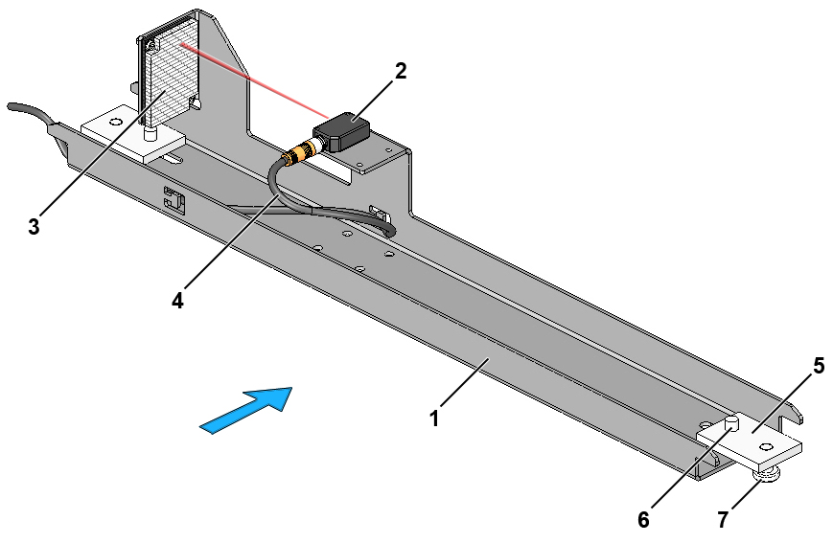
Fig. 1-1 Induction synchronization photocell, complete
1. | Bracket for induction synchronization photocell | 5. | Fixing plate
2. | Induction synchronization photocell | 6. | Guide screw
3. | Cable for photocell | 7. | Fixing screw
4. | Reflector

Preparation necessary
Installation of the following parts of the sorter must be complete before the induction synchronization photocell is installed:
- Supports
- Sections

Tools
Supplied Customer Tool Kit TT/CB 4000

Guides
- Electrical component location drawing
- I/O list

Installation guide
.1 Position the induction synchronization photocell on the mounting flanges of the cable trays in the sorter frame in accordance with the electrical component location drawing.
.2 Prepare the photocell bracket for installation by pushing the two fixing plates towards the middle of the bracket as shown in Fig. 1-2.
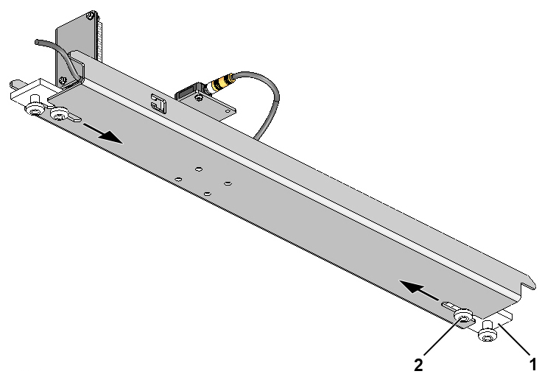
Fig. 1-2 Preparation of induction synchronization photocell for installation
1. | Fixing plate
2. | Guide screw, Torx 45, M8x16

.3 Install the induction synchronization photocell between the sorter section’s cable trays from below as shown in Fig. 1-3. Install the induction synchronization photocell from above if necessary for access reasons.
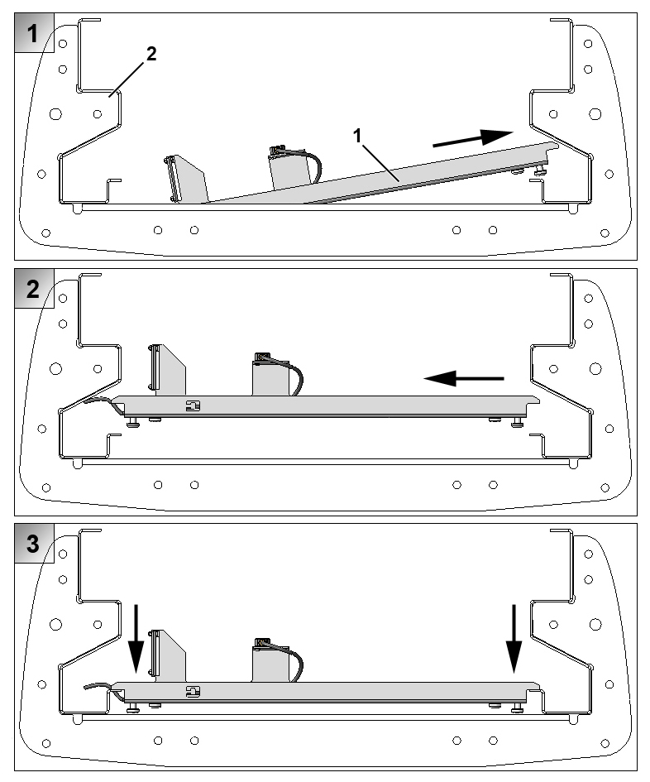
Fig. 1-3 Positioning of induction synchronization photocell in sorter section (as seen in direction of travel)
1. | Induction synchronization photocell
2. | Sorter section

.4 Push the two fixing plates in over the cable tray’s mounting flanges and tighten the two fixing screws and guide screws as shown in Fig. 1-4.
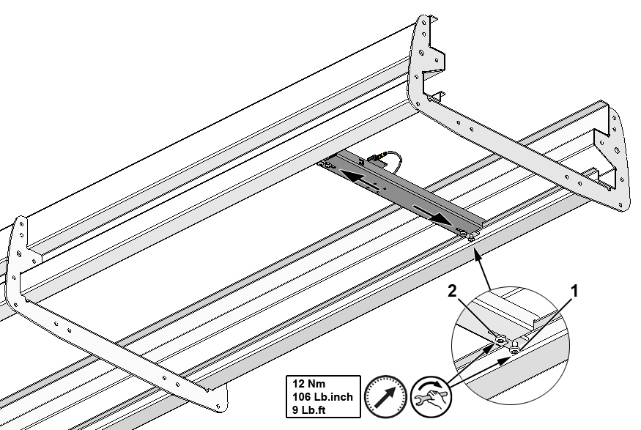
Fig. 1-4 Securing induction synchronization photocell
1. | Fixing screw, Torx 45, M8x16
2. | Guide screw, Torx 45, M8x16

.5 Connect the photocell in accordance with the I/O list.
.6 Secure the photocell cable with cable ties as shown in Fig. 1-5.
Please note that there should be at least a 20 mm gap between the photocell cable and the edge of the bracket once the cable has been secured.
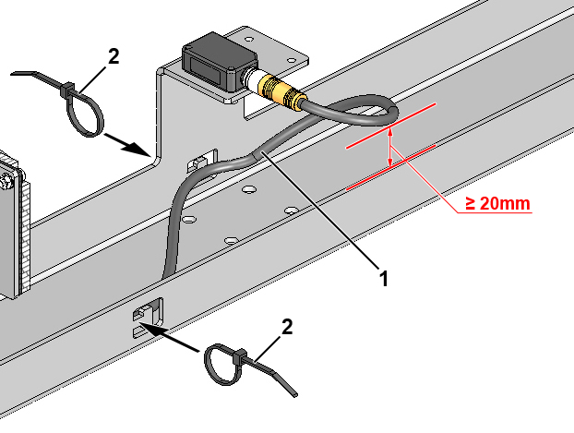
Fig. 1-5 Securing photocell cable
1. | Photocell cable
2. | Cable tie, 3.5 x 150 mm

